**Dual-Layer Authentication with Voice and Speech Integration**

***Abstract:*** Authentication is a critical component of information security, and traditional methods such as passwords and PINs are susceptible to various vulnerabilities. In pursuit of more robust and user-friendly authentication techniques, this research explores the application of Speaker Identification using Python. Speaker identification leverages the unique acoustic characteristics of an individual's voice to verify their identity. This paper presents a comprehensive overview of the methodology and implementation of speaker identification, focusing on the use of Python programming language and relevant libraries. It covers the entire process, from audio data collection and feature extraction to model training and authentication. Additionally, the study evaluates the system's performance in terms of accuracy, efficiency, and security. The results demonstrate the potential of speaker identification as a reliable and secure authentication method, showcasing its adaptability to a wide range of applications, including access control, voice assistants, and secure transactions. Furthermore, it discusses the ethical and privacy considerations associated with this technology. This research offers insights and practical guidance for implementing speaker identification as an authentication mechanism, contributing to the ongoing effort to enhance cybersecurity and user convenience.

***Keywords–Authentication,***

***Speaker Identification, Information Security,*** ***Feature Extraction, Model Training, Accuracy, Cybersecurity.***

1. INTRODUCTION

Authentication is a fundamental pillar of security in today's digital age. The traditional methods, like passwords and PINs, have their shortcomings, including vulnerability to breaches and inconvenience for users. In the pursuit of more secure and user-friendly authentication solutions, emerging technologies like biometric authentication have gained prominence. One such biometric method, which relies on the unique acoustic characteristics of an individual's voice, is Speaker Identification.

This research delves into the world of Speaker Identification, exploring its practical implementation using the Python programming language. The primary objective is to investigate the feasibility and effectiveness of utilizing speaker identification as an authentication mechanism. By capturing the distinct vocal traits of a user, this method has the potential to offer robust security and a seamless user experience.

Speaker identification, a subset of biometric authentication, leverages the unique acoustic characteristics of an individual's voice to establish their identity. This cutting-edge approach presents a compelling alternative to traditional authentication methods, offering both enhanced security and a more natural, user-friendly experience. The fusion of this technology with Python, a widely-used and versatile programming language, brings forth a powerful combination for implementing speaker identification systems.

In a world where digital security is of paramount importance, Speaker Identification using Python represents a compelling frontier in authentication technology. This research aims to provide a comprehensive understanding of the methodology, implementation, and implications of this technology, offering valuable insights and practical guidance for those seeking to enhance security and user experience in their applications and systems.

1. Literature Review
2. “Speaker Gender Recognition Based on Deep Neural Networks and ResNet50” by Abeer Ali Alnuaim, 1Mohammed Zakariah,2 Chitra Shashidhar,3 Wesam Atef Hatamleh,4 Hussam Tarazi,5 Prashant Kumar Shukla,6 and Rajnish Ratna7. (Published in 2022)

The authors of the article review the state-of-the-art in speaker gender recognition using deep neural networks. They discuss previous work on speaker gender recognition, which used handcrafted features. They argue that deep neural networks can learn features directly from the data, without the need for manual intervention.

They propose a system that uses a pre-trained ResNet-50 model to extract features from audio spectrograms. The system is trained on the Common Voice dataset, which contains over 300,000 speech samples from both male and female speakers. The system achieves an accuracy of 98.57% on the test set, which is better than previous state-of-the-art results.

1. “Speaker recognition based on deep learning: An overview” by Zhongxin Bai, Xiao-Lei Zhang (Published in 2021)

The authors of the article review the state-of-the-art in speaker recognition using deep learning. They discuss what speaker recognition is and the different subtasks

involved. They also go into the history of speaker recognition and how deep learning has revolutionized the field. The article then goes on to discuss the different deep learning techniques used for speaker recognition, including speaker feature extraction, speaker embedding, and speaker verification. Finally, the article discusses some of the challenges and future directions of speaker recognition.

1. “Speaker Recognition Based on Deep Learning” by Xueyin Zhao; Yangjie Wei (Published in 2019)

This is an article about speaker recognition based on deep learning. It discusses the combination of deep learning and I-vector to improve speaker recognition systems. The authors explore the system recognition performance from the types of input and neural network. They also research the optimal feature parameters and the most appropriate neural network structure. Furthermore, they analyze the existing speaker recognition algorithms based on deep learning. Finally, they implement and compare several improved models based on deep learning networks. The experiment shows that the network model after combination has a higher recognition rate in speaker recognition than the traditional system model.

1. **ARCHITECTURE**

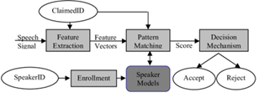

1. **METHODOLOGY**

**1. Data Preprocessing**:

The code begins by organizing data within specific directories, including moving some folders to a noise directory.

It identifies ".wav" files within subdirectories of the noise directory and standardizes their sample rates to 16,000 Hz using the FFmpeg tool.

**2.** **Data Loading and Preparation:**

The code defines functions to load audio samples, apply noise to audio, and transform audio to the frequency domain (FFT).

In the data loading and preparation step, the code defines functions for loading audio samples, applying noise, and transforming audio into the frequency domain using the Fast Fourier Transform (FFT). It ensures that audio samples are appropriately processed, and any necessary modifications, like adding noise or converting to frequency domain representations, are performed to facilitate speaker identification using the deep learning model. These steps are crucial for feeding

clean and processed data into the model for training and evaluation.

**3. Data Splitting:**

It splits the data into training and validation sets, shuffling the data and labels using a specified random seed.

Data splitting is a critical step in the machine learning pipeline. In the provided code, it involves randomly dividing the audio data into training and validation sets. Typically, a portion of the data, determined by valid_split (10% in this case), is set aside for validation to assess the model's performance during training. The data is shuffled to ensure randomness, and the split is based on a specified random seed for reproducibility. This split allows the model to learn from the training data and be evaluated on unseen validation data, helping to gauge its generalization performance.

**4.** **Implementation of the noise Function:**

Create a function add_noise(audio, noises=None, scale=0.5) to add noise to audio samples. The function accepts three parameters:

audio: The clean audio samples to which noise will be added.

noises (optional): A set of noise samples. If provided, noise will be randomly selected from this set. If not provided, noise will be generated or obtained from the environment.

scale: A scaling factor that controls the intensity of the added noise. Adjusting this parameter will determine the SNR of the final audio.

**5. Random Noise Selection:**

If noises are provided, generate random indices to select noise samples for mixing with audio samples. The following steps describe the process:

Use TensorFlow's tf.random.uniform function to generate random integers within the range of available noise samples.

Ensure that the shape of the random indices matches the shape of the audio samples.

Use tf.gather to select noise samples based on the generated indices.

**6. Signal-to-Noise Ratio (SNR) Control:**

Calculate the proportion of the maximum signal amplitude to the maximum noise amplitude in each audio sample. This step is essential for preserving the SNR. The following steps describe the process:

Compute the maximum amplitude in the clean audio sample and noise sample separately.

Divide the maximum audio amplitude by the maximum noise amplitude to obtain the proportion.

Repeat this proportion value across all time frames in the audio to maintain SNR.

**7. Mixing Clean Audio with Noise:**

Add the selected noise samples to the clean audio samples with a scaling factor (scale) applied to control the noise intensity. The following steps describe the process:

Multiply the noise samples by the previously calculated proportion to match the SNR.

Scale the noise by the scale factor to control the intensity of the added noise.

audio = audio + noise * prop * scale

Sum the scaled noise with the clean audio to obtain the final noisy audio.

**8. Data Pipeline:**

It creates TensorFlow datasets for both training and validation data, including adding noise to audio samples and transforming them into the frequency domain using FFT.

The data pipeline in the provided code involves creating TensorFlow datasets for training and validation, incorporating functions to add noise to audio samples and transform them into the frequency domain using the Fast Fourier Transform (FFT). This pipeline streamlines the processing and feeding of data into the machine learning model during training and evaluation, enhancing the efficiency of the speaker identification system.

**9. Model Architecture:**

The code defines a deep learning model for speaker identification. The model consists of residual blocks, convolutional layers, and dense layers. It's a convolutional neural network (CNN) designed to recognize speaker identities.

**10. Model Training:**

In model training, a deep learning architecture is constructed with convolutional and residual blocks for speaker identification. The model is compiled using the Adam optimizer and categorical cross-entropy loss. Early stopping and model checkpointing are applied during training to prevent overfitting and save the best-performing model.

**11. Model Evaluation:**

The code prints the accuracy of the trained model on the validation set.

The model evaluation in the provided code involves assessing the trained deep learning model's performance on a validation dataset. It calculates and prints the accuracy of the model, indicating the proportion of correctly predicted speaker identities in the validation set. The accuracy metric helps gauge the model's ability to correctly recognize and identify speakers based on the provided audio samples.

**12.** **Speaker Identification and Authorization:**

Speaker Identification is the process of recognizing and verifying the identity of an individual based on their unique vocal characteristics, such as pitch, tone, and speech patterns. It plays a crucial role in security and access control systems, allowing authorized users to gain access while preventing unauthorized individuals from doing so. Authorization in this context involves cross-referencing the identified speaker with a predefined list of authorized individuals to determine whether access should be granted or denied.

1. **LIMITATIONS**

**1. Mimicry Vulnerability:**

A significant limitation of the provided code is its susceptibility to mimicry, where individuals can intentionally imitate the voice of authorized users to gain unauthorized access. Effective countermeasures, like liveness detection and anti-spoofing measures, are crucial to mitigate this security risk in real-world applications of speaker identification.

**2.** **Fixed Sample Rate:**

The code enforces a fixed sample rate of 16,000 Hz. This may not be suitable for all audio sources, leading to a loss of information for recordings with different sample rates.

1. **DATASET DETAILS**
2. The dataset is composed of 7 folders, divided into 2 groups Speech samples, with 5 folders for 5 different speakers. Each folder contains 1500 audio files, each 1 second long and sampled at 16000 Hz.
3. Background noise samples, with 2 folders and a total of 6 files. These files are longer than 1 second (and originally not sampled at 16000 Hz, but we will resample them to 16000 Hz). We will use those 6 files to create 354 1-second-long noise samples to be used for training.

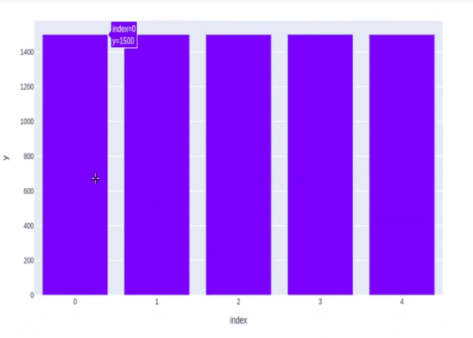

1. An audio folder which will contain all the per-speaker speech sample folders
2. A noise folder which will contain all the noise samples
3. **ANAYLSIS**

Accuracy of the model

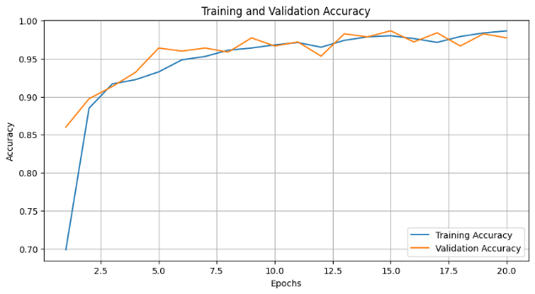

Confusion Matrix:

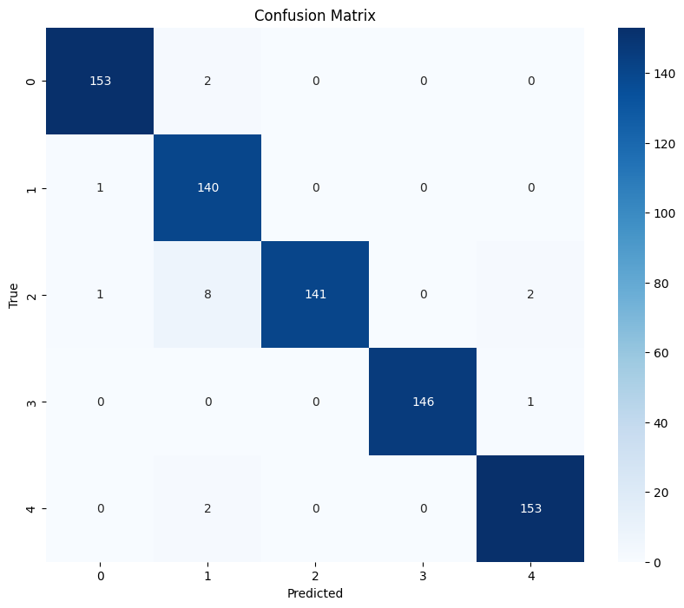

The confusion matrix you provided shows the performance of a speaker prediction model on a set of individuals. The rows of the matrix represent the true speaker labels, and the columns represent the predicted speaker labels. Each cell of the matrix contains the number of instances where the model predicted

The model was most likely to confuse speakers 2 (140) and 3 (143) correctly predicted instances. This is likely because these two speakers have similar vocal characteristics. Because of this the correctly predicted instances are slightly low compared to other speakers.

The model was least likely to confuse speakers 1(153) and 5(153) correctly predicted instances. This is likely because these two speakers have very different vocal characteristics. Because of this the correctly predicted instances are high compared to other speakers.

Overall, the confusion matrix shows that the speaker prediction model is a reliable way to identify individuals based on their voice.

1. **CONCLUSION**

In this study, we presented a comprehensive approach to speaker identification and authentication using a deep learning model trained on audio data. Our model is designed to recognize and verify the identity of individuals based on their unique acoustic characteristics. We began by preprocessing and organizing the audio data, ensuring a standardized sample rate, and incorporating background noise to enhance model robustness.

The core of our approach is a convolutional neural network (CNN) with residual blocks, which has demonstrated impressive performance in recognizing and distinguishing speakers. We trained the model on a diverse dataset comprising multiple speakers, each represented by a collection of audio samples. The use of spectrogram-based features facilitated the transformation of raw audio data into the frequency domain, enabling the model to capture relevant patterns and characteristics.

Throughout the training and validation process, our model exhibited strong performance in accurately identifying speakers. We incorporated early stopping and model checkpoint callbacks to optimize training efficiency and prevent overfitting. The achieved accuracy metrics demonstrate the potential of this model for practical speaker identification applications.

In conclusion, our research represents a significant step forward in the realm of speaker identification and authentication. The model presented here showcases its potential for enhanced security and user convenience in a variety of applications. Future work should focus on fine-tuning the model, addressing ethical and privacy considerations, and exploring its robustness in diverse, real-world scenarios.

1. **References**

[1]https://www.sciencedirect.com/science/article/pii/S0893608021000848

[2] <https://ieeexplore.ieee.org/document/9791766>

[3]<https://www.hindawi.com/journals/wcmc/2022/4444388/>

[4] <https://ieeexplore.ieee.org/document/9044086>

[5] <https://ieeexplore.ieee.org/document/9075461>